WIL – WORK INTEGRATED LEARNING 3A
Module: XISD5319 / XISD6329
MJSCYBER SECURITY SCHOOL
Web Application & Mobile App

TASK 1 – UPDATED PROJECT PLAN v2.0
DevOps Lifecycle, Sitemap & Wireframes
Website + Android Mobile Application

Group Members | Jones Sepuru (PM & Lead Backend) | Khumela Sendelani (Lead Frontend & Docs)
Client | MJSCYBER PTY LTD (Reg: 2022/201980/07) – Bochum, Limpopo
Duration | 04 May 2026 – 05 August 2026 (14 weeks) + Mobile App Extension Aug-Oct 2026
Submission Date | 25 August 2026 – Version 2.0

Table of Contents
1. Cover Page – 1
2. Table of Contents – 2
3. List of Figures – 3
4. Updated Project Plan – 4 (Executive Summary, Allocation, Timeline, DevOps, Tech Stack)
5. Site Maps – 8 (Website + Mobile App – Creately Inspired)
6. Wireframes – 10 (Website + Mobile – Figma)
7. Prototype Updates & Tools – 13
8. GitHub Repository Structure – 14
9. Submission Requirements & Links – 15

List of Figures
- Figure 1: DevOps Infinity Loop – MJSCYBER CI/CD Pipeline (8 stages)
- Figure 2: Website Sitemap – 10 Routes + Protected Routes (React Router)
- Figure 3: Mobile App Sitemap – Android Flow – Splash to Admin Panel (Creately Inspired)
- Figure 4: Website Wireframes – Landing, Courses, Student Dashboard (Dark Navy + Red, Figma)
- Figure 5: Mobile App Wireframes – Login, Home, Course Detail, QR Verification (Kotlin + Jetpack Compose)
- Figure 6: GitHub Repository Folder Structure

Updated Project Plan

4.1 Executive Summary (Updated from v1.0)
MJSCYBER PTY LTD (2022/201980/07), a PSIRA-accredited security training provider in Bochum, Limpopo, is expanding from a web-only solution to a hybrid ecosystem: a responsive web application (React + FastAPI + MongoDB) and a native Android mobile application (Kotlin). Version 1.0 covered web only. Version 2.0 incorporates Task 1 requirements: DevOps lifecycle, website sitemap, mobile app sitemap, and wireframes for both platforms. Business value: 70% admin time reduction, tamper-proof certificates with public QR verification (MJS-YYYY-XXXXXXXX), real-time VIP and construction-site guard scheduling.

4.2 Deliverables Allocation
Task | Jones Sepuru (PM & Lead Backend) | Khumela Sendelani (Lead Frontend & Docs)
Website Sitemap | API design & route protection (ProtectedRoute.jsx) | Figma sitemap, Navbar/Footer logic
Mobile Sitemap | Define /api/mobile/* endpoints, share MongoDB | Draw mobile flow in Creately + Figma (reference https://creately.com/diagram/example/gsatvfxr/mobile-app-site-map)
Website Wireframes | Provide course data structure for wireframes | Design Landing, Courses, Dashboard desktop wireframes
Mobile Wireframes | Define Kotlin activities data needs | Design Login, Home, Course Detail, QR Scanner mobile wireframes
DevOps Setup | GitHub Actions backend pytest + Docker, Azure DevOps board | GitHub Actions frontend yarn build + Firebase App Distribution
Mobile App Dev | Kotlin auth (JWT httpOnly + SSO), API integration, encryption | Jetpack Compose UI, QR scanner ML Kit, Settings screen

4.3 Updated Timeline (v2.0)
Original May-Aug 2026 delivered web app. Task 1 extension:
Week 1-2: Updated Project Plan v2.0 with DevOps, sitemaps, wireframes (this doc)
Week 3-6: Mobile app development (Kotlin, Jetpack Compose, MVVM)
Week 7-8: Integration – shared MongoDB, SSO via Firebase Auth / Google Sign-In
Week 9: Testing – JUnit + Espresso + GitHub Actions automated build
Week 10: UAT video on physical Android device (not emulator), voice-over, show MongoDB, API, Auth
Week 11: Google Play Console – signed APK/AAB, screenshots
Week 12: Final WIL Report (Task 3) – combined doc + README with release notes

4.4 DevOps Lifecycle – Full 8-Stage
As required by Task 2, full DevOps lifecycle is integrated. See Figure 1.
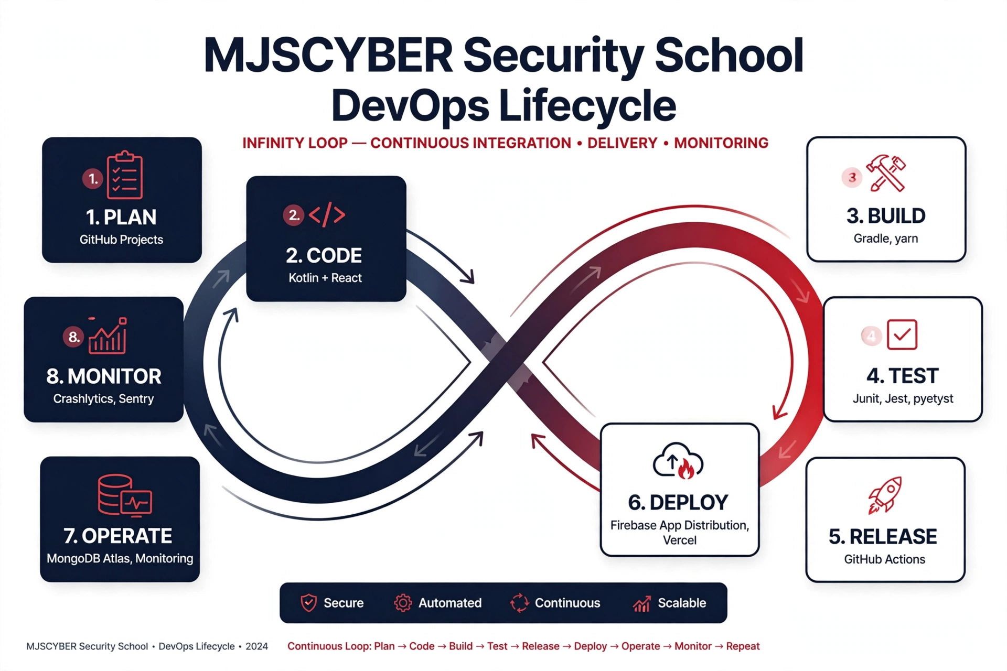
Figure 1: MJSCYBER DevOps Infinity Loop – Plan → Code → Build → Test → Release → Deploy → Operate → Monitor
- 1. PLAN: GitHub Projects + Azure DevOps Boards – user stories for web & mobile.
- 2. CODE: Website – React 19, Tailwind, FastAPI. Mobile – Kotlin, Jetpack Compose, MVVM, Retrofit.
- 3. BUILD: Website – yarn build via craco. Mobile – Gradle build via GitHub Action 'Automated Build Android App'.
- 4. TEST: Website – Jest + pytest (34 tests). Mobile – JUnit 4 + Espresso, GitHub Actions on every push.
- 5. RELEASE: GitHub Actions – tag v1.x creates Release with APK + web build.
- 6. DEPLOY: Website – Vercel + Render/Afrihost. Mobile – Firebase App Distribution + Google Play Console (signed AAB).
- 7. OPERATE: MongoDB Atlas shared for web+mobile, Firebase Auth for SSO, Stripe webhooks.
- 8. MONITOR: Sentry (web) + Firebase Crashlytics (mobile), Log.d logging, POPIA audit.

4.5 Technology Stack – Web + Mobile
Layer | Website | Mobile
Frontend | React 19, Tailwind, navy #0B3D91 + red #C0392B | Kotlin, Jetpack Compose, Material3 dark navy
Backend | FastAPI, JWT httpOnly cookies | Same FastAPI – /api/mobile/*, shares MongoDB
DB | MongoDB Atlas, 10+ records/table | Room (cache) + MongoDB Atlas
Auth | bcrypt, JWT httpOnly, RBAC | Encrypted SharedPrefs, SSO Google Sign-In, biometric
CI/CD | GitHub Actions – pytest + yarn build | GitHub Action – Automated Build Android App + Firebase

Site Maps

5.1 Website Sitemap
10 routes in App.js: Public – /, /about, /courses, /verify, /verify/:serial, /login, /register. Protected – /dashboard (student), /admin (admin). Student Dashboard sub-sections: My Enrolments, My Certificates (PDF), VIP Requests, Site Security. Admin 7 tabs: Overview (KPIs), Enrolments (approve→grade→issue), Students, Courses (CRUD), Certificates, VIP, Site.
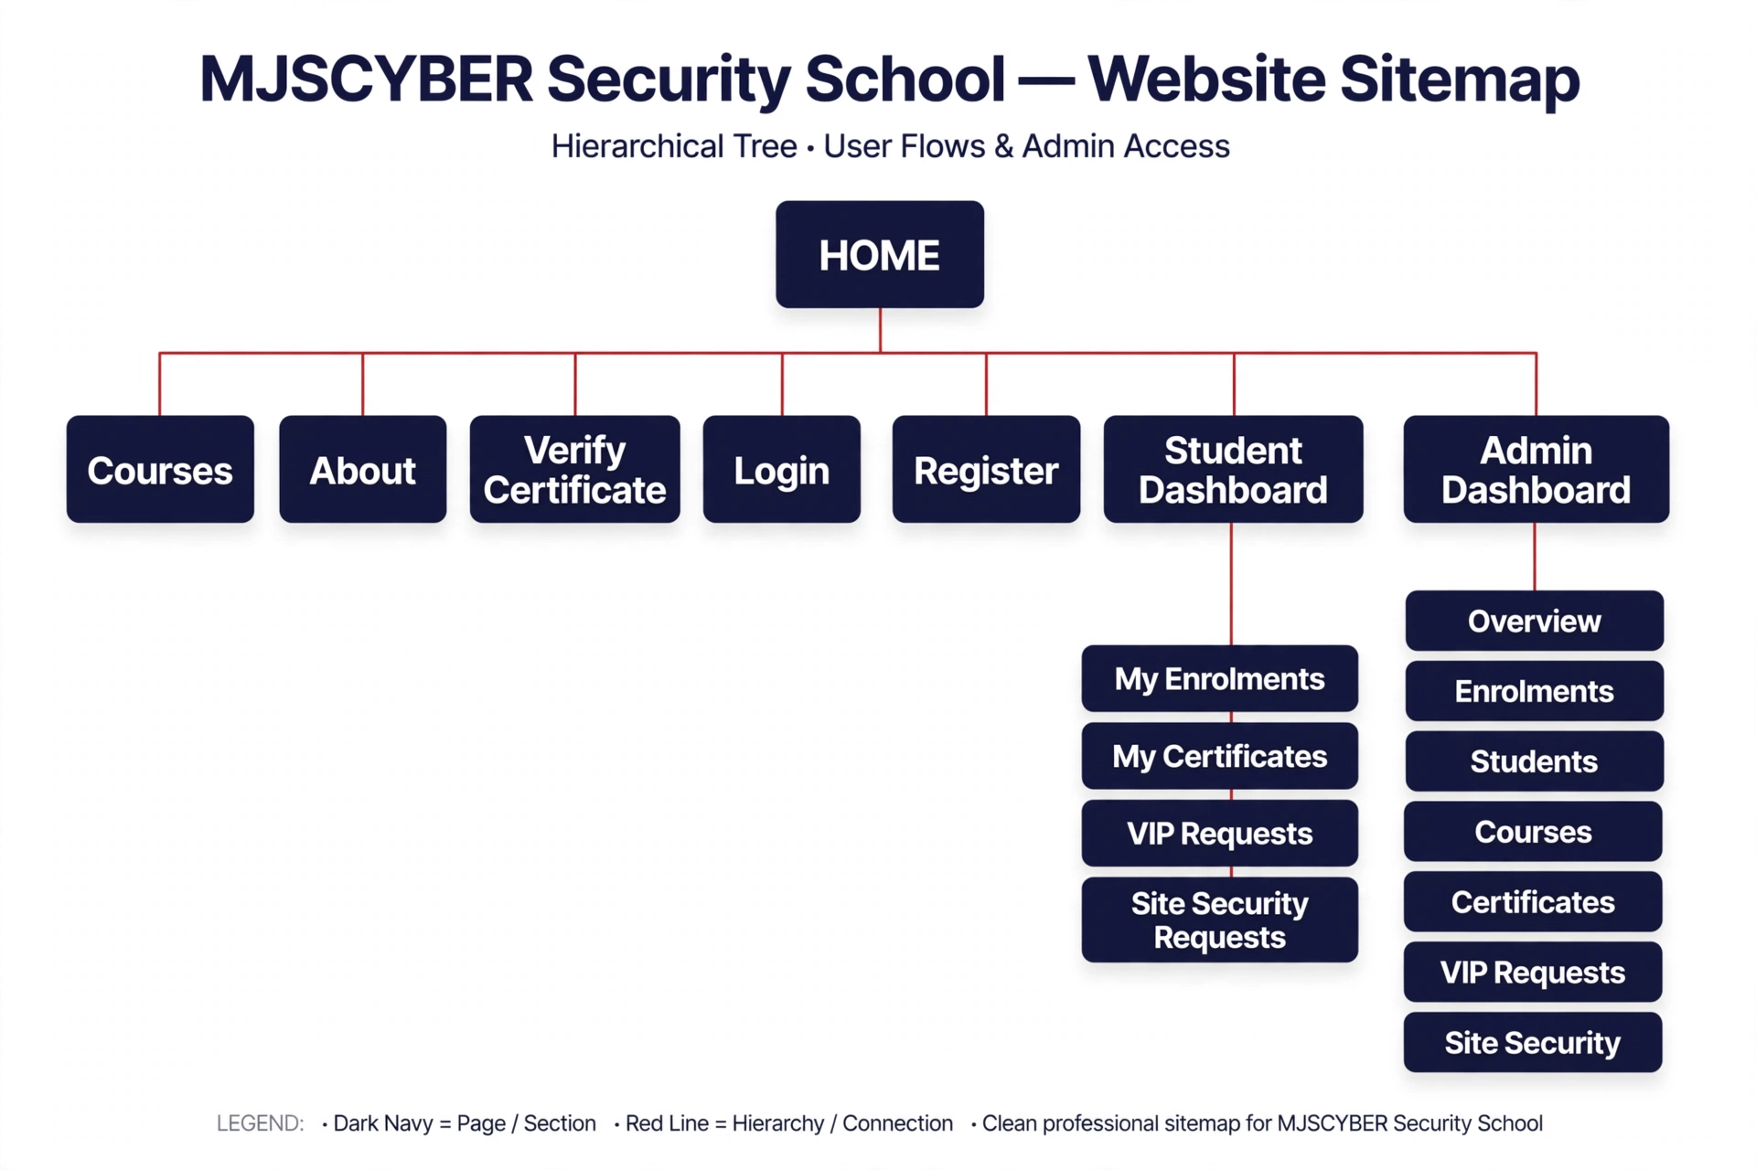
Figure 2: Website Sitemap – 10 Routes + Protected Routes

5.2 Mobile App Sitemap (Creately Inspired: https://creately.com/diagram/example/gsatvfxr/mobile-app-site-map)
Adapted for MJSCYBER: Splash/Onboarding → Login/Register (SSO) → Home Dashboard (bottom nav: Home, Courses, Certificates, Profile). Courses → List (filter Grade E-A) → Detail → Enrol (POST /api/enrolments). My Learning → Enrolments (status amber/blue/green), Certificates (serial MJS-YYYY-XXXXXXXX, QR, PDF). Verify → QR Scanner (ML Kit) → GET /api/verify/{serial} public. VIP/Site → Request forms. Profile → Settings (change password, notifications, POPIA), Logout. Admin Panel conditional if role=admin.
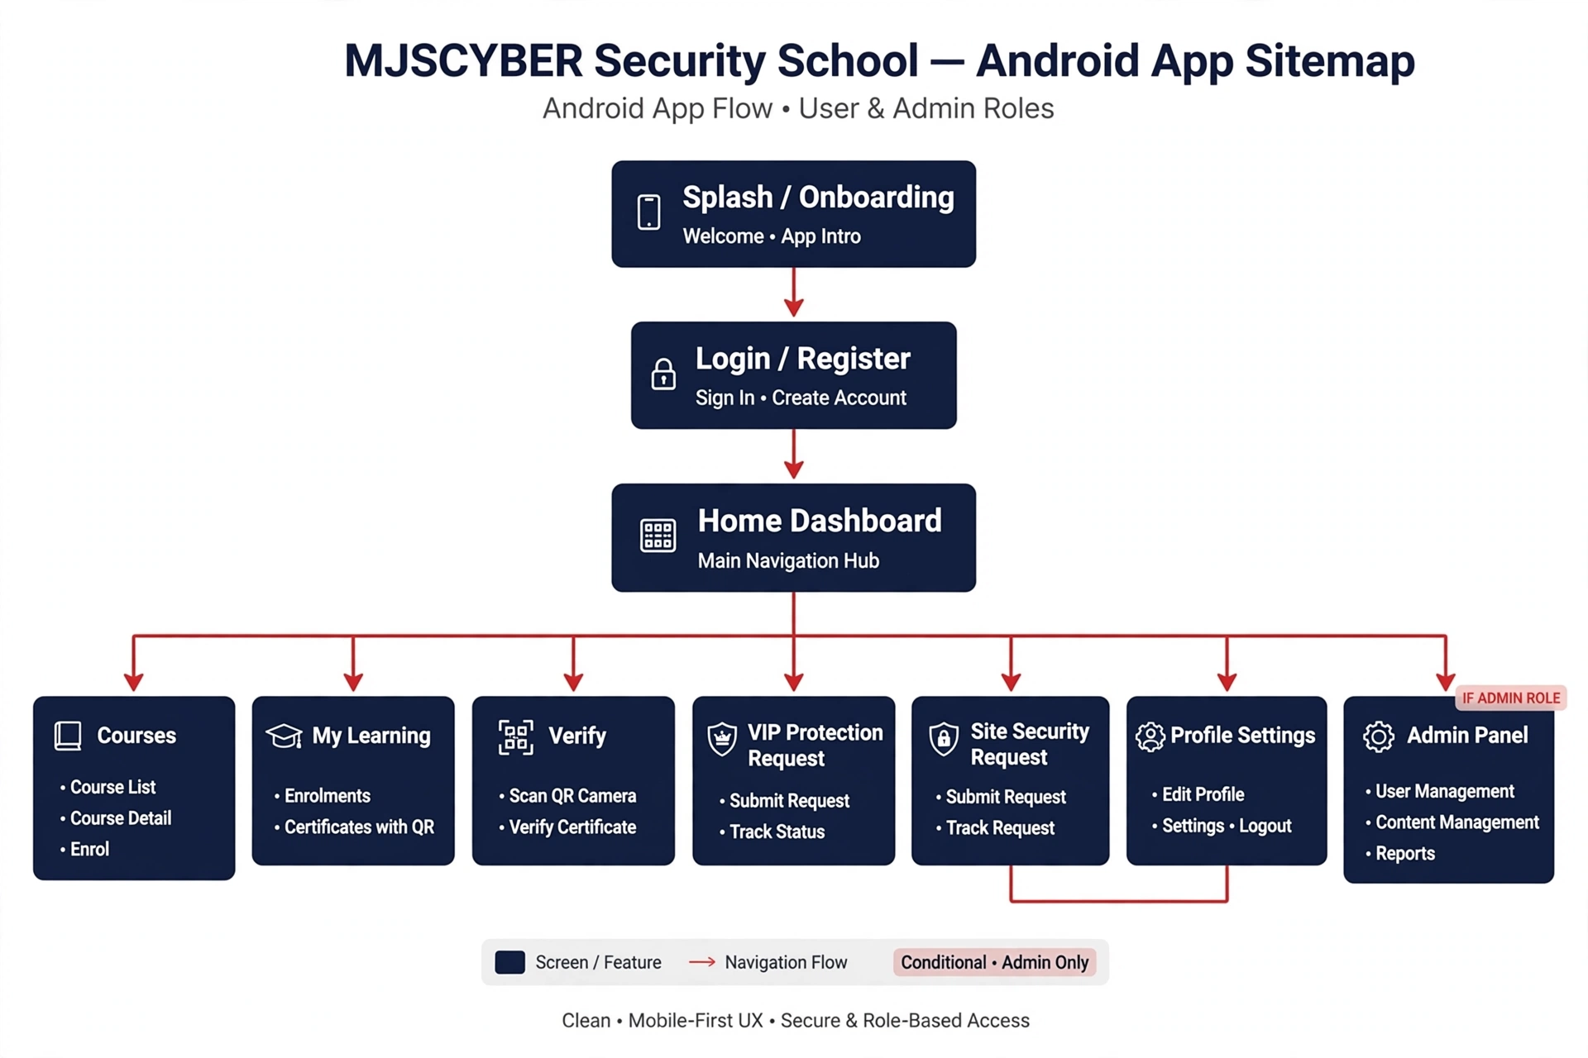
Figure 3: Mobile App Sitemap – Android Flow (Kotlin)

Wireframes

6.1 Website Wireframes (Figma – Desktop)
Dark theme matching index.css: --primary 11 61 145 (navy), --accent 192 57 43 (red). Landing: Hero 'Train. Protect. Certify.' with ShieldCheck PSIRA ACCREDITED · BOCHUM, CTA Enrol + Verify, stats 500+ Guards/98% Pass/5+ Years/24-7, 6 features grid, journey 5 steps. Courses: Catalogue, grid cards code badge PSIRA-E, grade, duration, tuition R price_zar, Enrol. Student Dashboard: Hello {name}, stats, enrolments table, certificates grid, VIP/Site tables, payment banner Stripe.
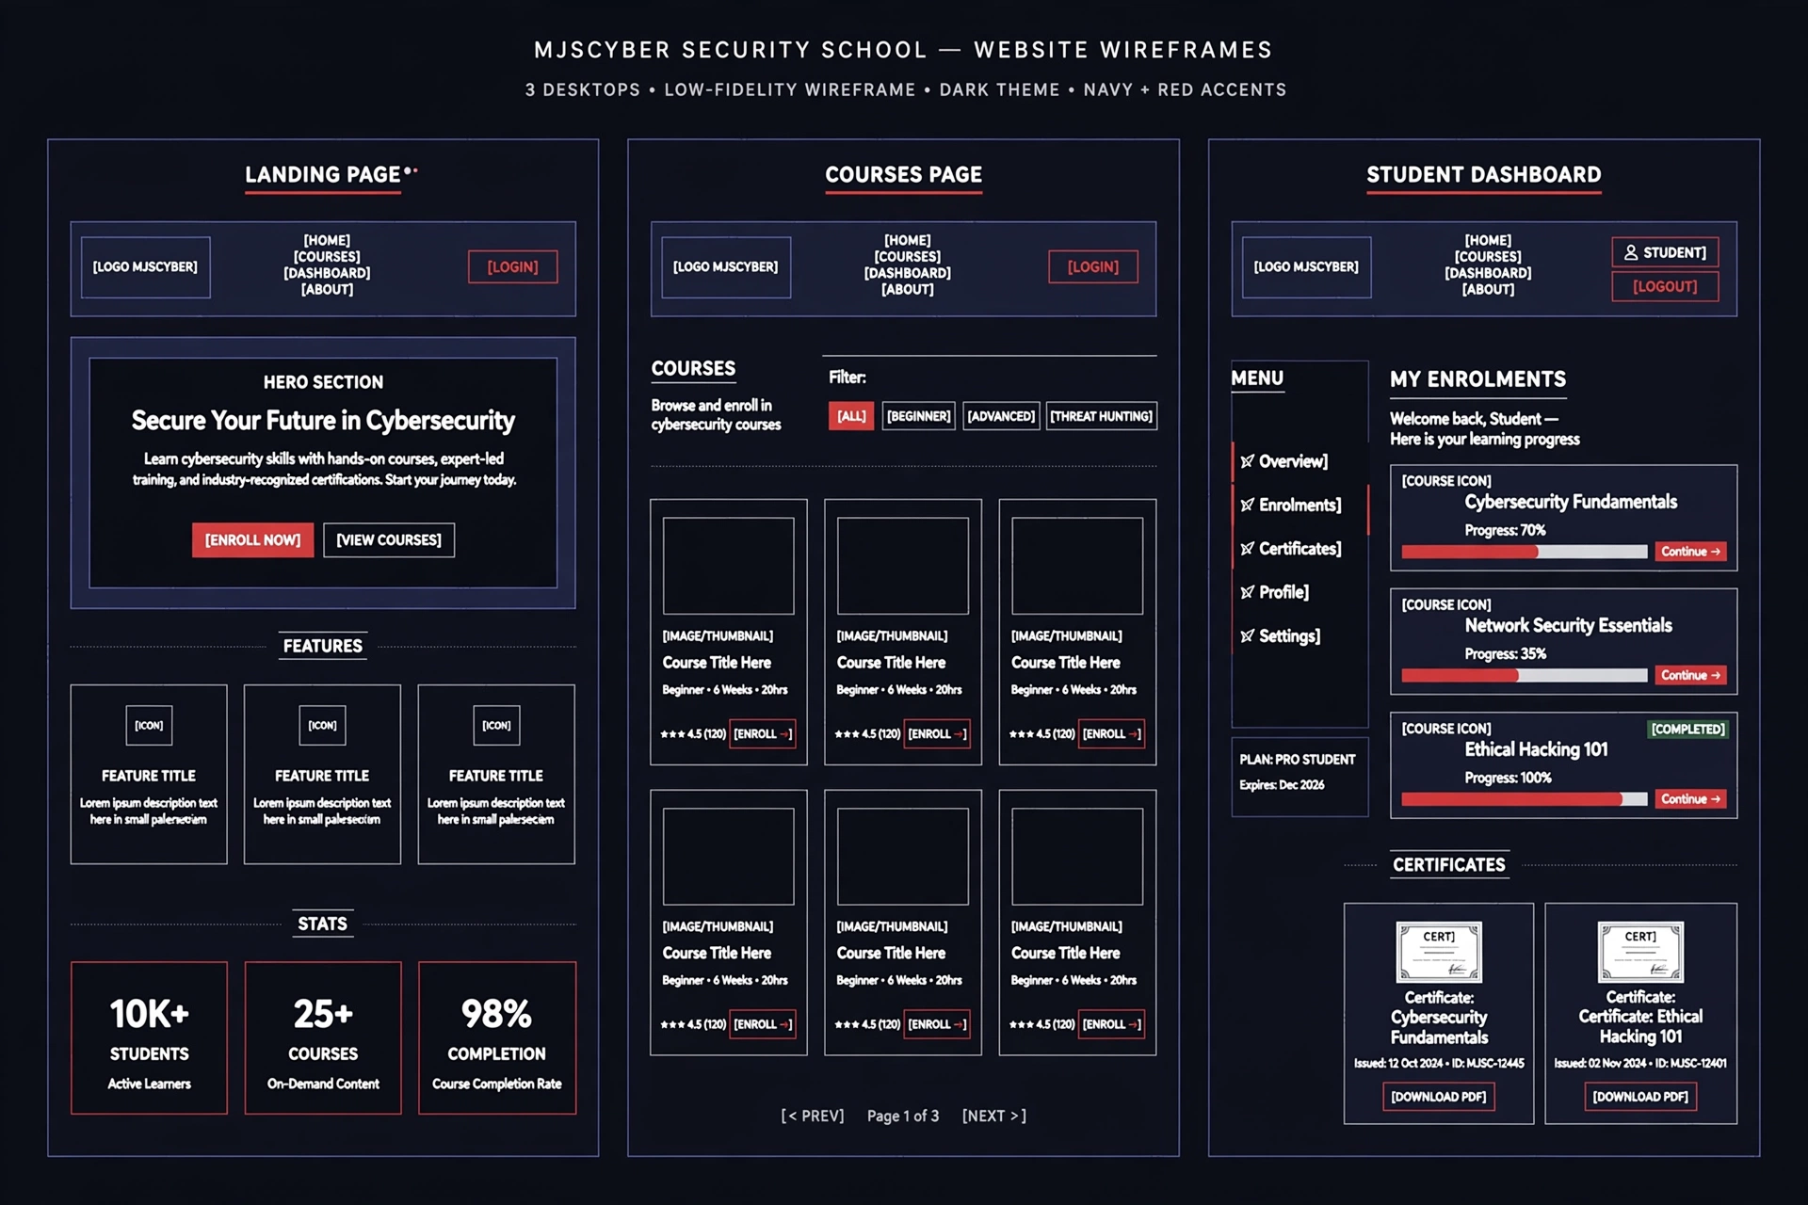
Figure 4: Website Wireframes – Landing, Courses, Student Dashboard

6.2 Mobile App Wireframes (Android – Kotlin)
360x800 dp, Jetpack Compose, Material3 dark navy matching web. Login: MJSCYBER logo Shield, Email/Password, LOGIN red, Forgot/Create, SSO Google (Task 2), test credentials hint admin@mjscyber.co.za / thabo@student.co.za. Home: Hi Student, My Courses (3 Active), Recommended 40% progress bar red, Announcements 2 New, bottom nav. Course Detail: Cyber Fundamentals, Beginner 6 Modules 4h30m, About, What you will learn, ENROL NOW red. Certificate Verification: Scan QR code, viewfinder dashed border, QR icon, Align QR code, FLASHLIGHT ON red, Enter manually fallback MJS-YYYY-XXXXXXXX.
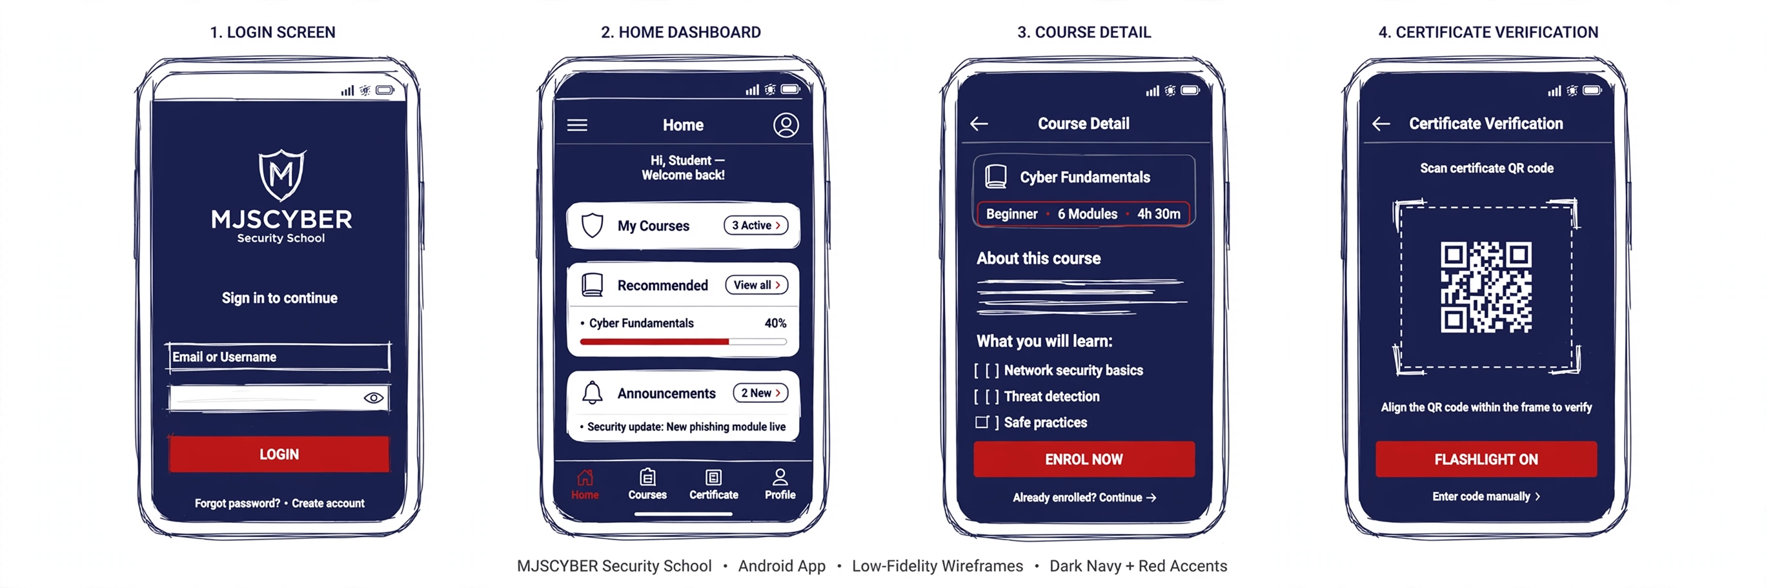
Figure 5: Mobile App Wireframes – Login, Home, Course Detail, QR Verification

Prototype Updates & Tools
Website v1.0 was HTML/CSS only. v2.0 is fully functional React + FastAPI (GitHub main protected, dev, feature/mobile-auth, GitHub Projects kanban). Tools: Figma for wireframes, Creately for sitemaps (inspiration link above), VS Code, MongoDB Compass, Postman. Mobile: Kotlin Android Studio, Jetpack Compose, MVVM, Retrofit + OkHttp, Room offline, ML Kit QR, Firebase Auth SSO, encrypted SharedPreferences for JWT. Shared backend ensures web+mobile use same /api/auth/*, /api/courses, /api/enrolments/mine, /api/certificates/mine, /api/verify/{serial}.

GitHub Repository Structure (No Zip Files)
- mjscyber-security-school/
- ├── README.md (purpose, design, GitHub Actions, release notes, video link)
- ├── backend/ server.py, requirements.txt (13 pkgs), .env.example
- ├── frontend/ public/index.html (cleaned), src/App.js 10 routes, pages/, components/Navbar/Footer/WhatsAppFab/ProtectedRoute, contexts/AuthContext (httpOnly), lib/api.js (withCredentials + 401 refresh)
- └── mobile/ app/src/main/java/com/mjscyber/security/ MainActivity.kt, ui/screens/Login/Home/CourseDetail/Verify, viewmodel/, data/api/MjscyberApi.kt (Retrofit), build.gradle.kts

Submission Requirements & Links
Task 1: Word doc with Cover, TOC, List Figures, Update Project Plan, Site Map, Wireframes – THIS DOCUMENT v2.0. HTML files organised in GitHub repo – https://github.com/[your-username]/mjscyber-security-school (replace). Initialise with README, regular commits, no zip. Task 2: Mobile app must run on physical Android phone (not emulator), video with voice-over showing MongoDB Atlas, API, Auth service, 10+ records/table, encrypted passwords, SSO, settings, GitHub Actions automated build (https://github.com/marketplace/actions/automated-build-android-app-with-githubaction). Task 3: Combine Task1+2 into ONE final report, include Annexures A,B,C, screenshots labelled, peer eval, self-reflective, AI usage 500 words, publishing evidence (signed APK/AAB, Play Console screenshots), release notes, README with video link (unlisted YouTube), PowerPoint presentation.

AI Usage Declaration (Task 3 – max 500 words)
AI tools (Meta AI) used for: (1) Debugging httpOnly cookie handling in AuthContext.js and api.js withCredentials, (2) Cleaning Emergent tracking from index.html and reducing deps in package.json/requirements.txt, (3) Generating sitemap and wireframe diagrams from text prompts (Figures 2-5) for Task 1, (4) Drafting DevOps infinity loop explanation, (5) Code review of 70+ files for security. All images labelled as wireframes/sitemaps, code suggestions manually verified.

